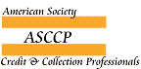
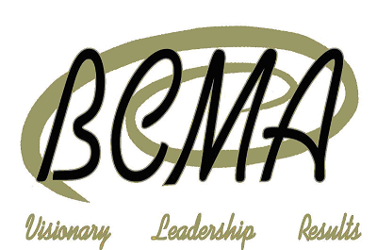

Accreditation Review & Evaluation Request

If there are reasons for and situations that you believe have changed the status of your CCP or CPC approval, the Credentialing Standards Board will re-open your file for review and further evaluation. The re-evaluation will detail and explain what further activity, education or experience may be required in order to obtain and be approved for an additional credential. Your request for review does not automatically assure you that you will be awarded the additional credential you aspire to be awarded.

Attached is your original Application for Council Record upon which the Credentialing Standards Board (CSB) based their decisions on when you were initially awarded your credential. You are asked to provide written notice of additional experience and involvement in credit and collection management that will justify the CSB awarding the additional credential you seek.

Complete this form and return it to the BCMA offices location listed on this form along with additional documentation that you feel helps you meet certification requirements. The time frame for re-evaluation is approximately 6 weeks.

1. CSB File #: _________ BCMA Member? Yes No Review Requested For CPC CCP

2. Name: ___________________________________________________________________________________
LAST FIRST MIDDLE
4. Company: ____________________________________________________________________
5. Mailing Address Preference: Home Business
6. Address: _________________________________________
City: State/Prov: Zip/Postal Code: __________________
7. Phone: _______________________ Email: __________________________________________
8. Review and Re-evaluation Fees:
BCMA Member $55.00
Non-Member $195.00

9. Method of Payment: Check American Express MasterCard Visa Invoice Me
Card Number: _______________________________ Expiration Date: ________________
Signature: ________________________________________________________________
Mail, fax or email required materials to:
FOR BCMA OFFICE USE ONLY

CC/CK# __________________
ID# _____________________
AMT $____________________
LB DATE __________________
American Society of Credit & Collection Professionals
C/O Business Credit Management Association
PO Box 510157
New Berlin WI 53151
Phone: 262.827.2880
Fax: 262.827.2899
admin@wcacredit.org
www.creditsociety.org

